Project Design Phase-II

Technology Stack (Architecture & Stack)
Date: 31 January 2025
Team ID: LTVIP2026TMIDS91486
Project Name: HematoVision – Intelligent Blood Cell Classification System
Maximum Marks: 4 Marks
Technical Architecture
HematoVision follows a Machine Learning–Driven Application Architecture where users interact with a web-based interface that communicates with a backend prediction engine integrated with a transfer learning model. 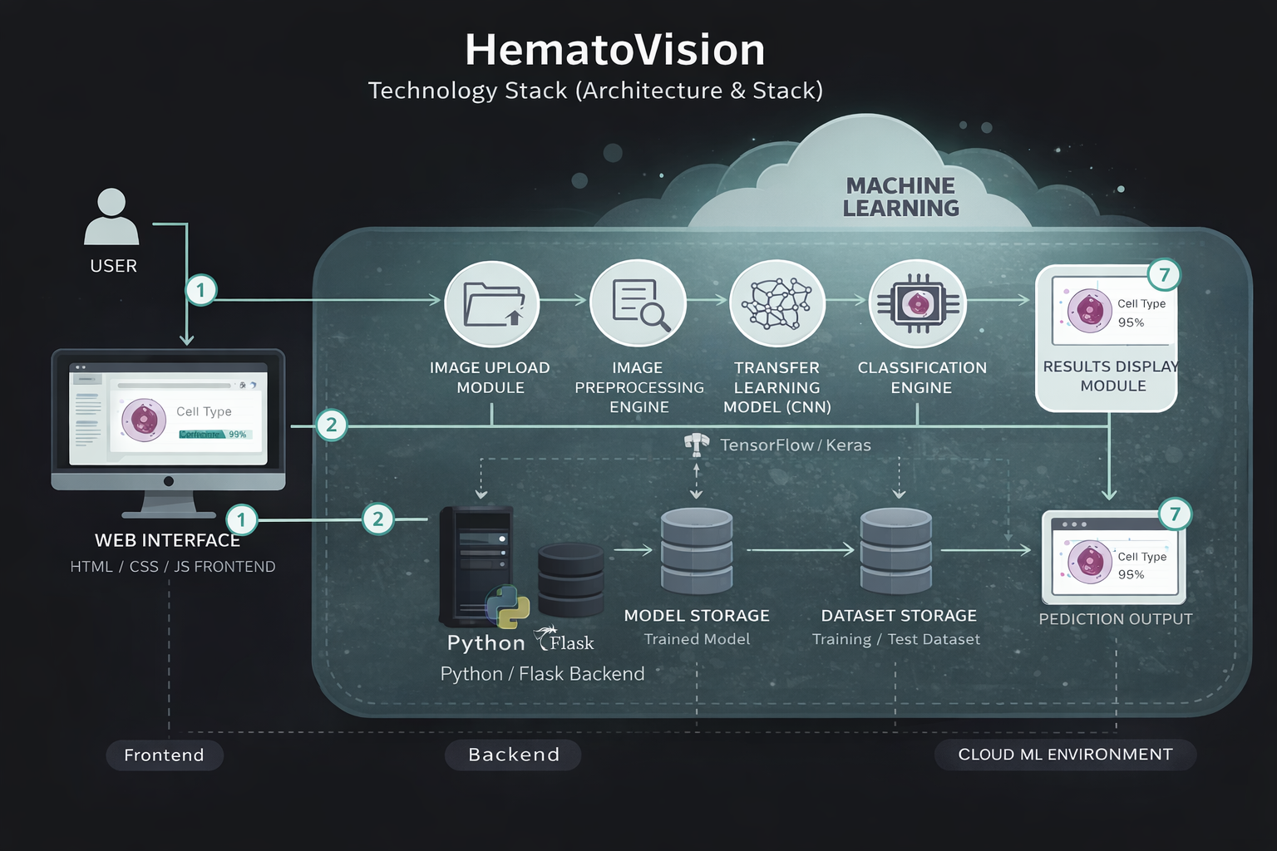

Table-1: Components & Technologies
S.No | Component | Description | Technology
1 | User Interface | Web-based interface for image upload & result visualization | HTML, CSS, JavaScript
2 | Application Logic-1 | Handles image upload & validation | Python (Flask / FastAPI)
3 | Application Logic-2 | Performs image preprocessing (resize, normalization) | Python, OpenCV / NumPy
4 | Application Logic-3 | Executes prediction using transfer learning model | TensorFlow / Keras
5 | Classification Engine | Converts extracted features into predicted labels | CNN Softmax Layer
6 | Database / Data Store | Stores metadata (optional) | SQLite / Local Storage
7 | File Storage | Stores uploaded images (temporary) | Local File System
8 | Dataset Storage | Training & testing images | Local Dataset Directory
9 | Machine Learning Model | Blood cell classification model using transfer learning | MobileNetV2 / Pretrained CNN
10 | Infrastructure (Server / Deployment) | Hosts application backend & model | Local Server / Flask Server

Table-2: Application Characteristics
S.No | Characteristics | Description | Technology / Approach
1 | Open-Source Frameworks | Frameworks used for development & ML | TensorFlow, Keras, Flask
2 | Security Implementations | Basic validation & safe file handling | Input Validation, File Type Checking
3 | Scalable Architecture | Modular ML-based layered design | UI → Backend → ML Engine
4 | Availability | System accessible during runtime | Local Server Execution
5 | Performance | Efficient inference using transfer learning | MobileNetV2 (Lightweight CNN)
6 | Reliability | Consistent predictions from trained model | Pretrained CNN + Fine-Tuning
7 | Maintainability | Easy model replacement & updates | Modular Backend Design
8 | Portability | Deployable across environments | Python-based Architecture

